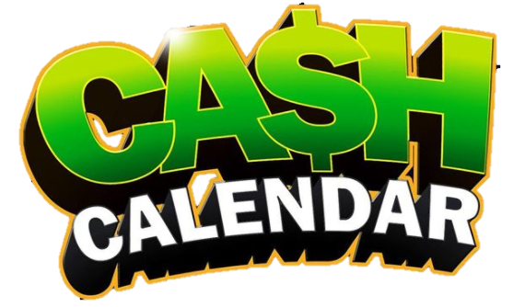
$5 Each
Prizes Daily
Multiple Chances to Win

Brunswick Volunteer Ambulance & Rescue Company 19 will be selling fundraising CASH CALENDARS for the months of October, November and December each month’s calendar are $5 each. Starting in June.
Drawings will begin on October 1, 2022, continuing thru December 31, 2022.

Cash Calendars will be available for sale at all BVAR
events in June thru November 30th.
You may also contact any member or send us an email
at michele.dilling@comcast.net
or 240-409-4114 to arrange for a calendar purchase or pickup.
All numbers are played straight as drawn.

All drawings will be based on the Maryland Evening Pick 3 Lottery drawings.
**Not affiliated with the Maryland Lottery**

